Ameren Missouri is better prepared for spring storms thanks to investments from their Smart Energy Plan (SEP) and investments in smart technology. These upgrades and more reduce outages and help Ameren respond more quickly when they do occur.

Be prepared for the storm season:

* Update your contact information with Ameren Missouri
* Check circuit breakers or fuses – some outages might be the result of a household problem.
* Once checked, report your outage to Ameren Missouri
* Customers can check on the status of their restoration on the outage map at Ameren.com or download the free Ameren app for updates as they become available
* Sign up for alerts – text REG to AMEREN (263736) to start or visit Ameren.com/Alerts

*REPORTING AN OUTAGE – when reporting, please use the phone number associated with the account. Entering a number that is not associated with the account will create an error message.

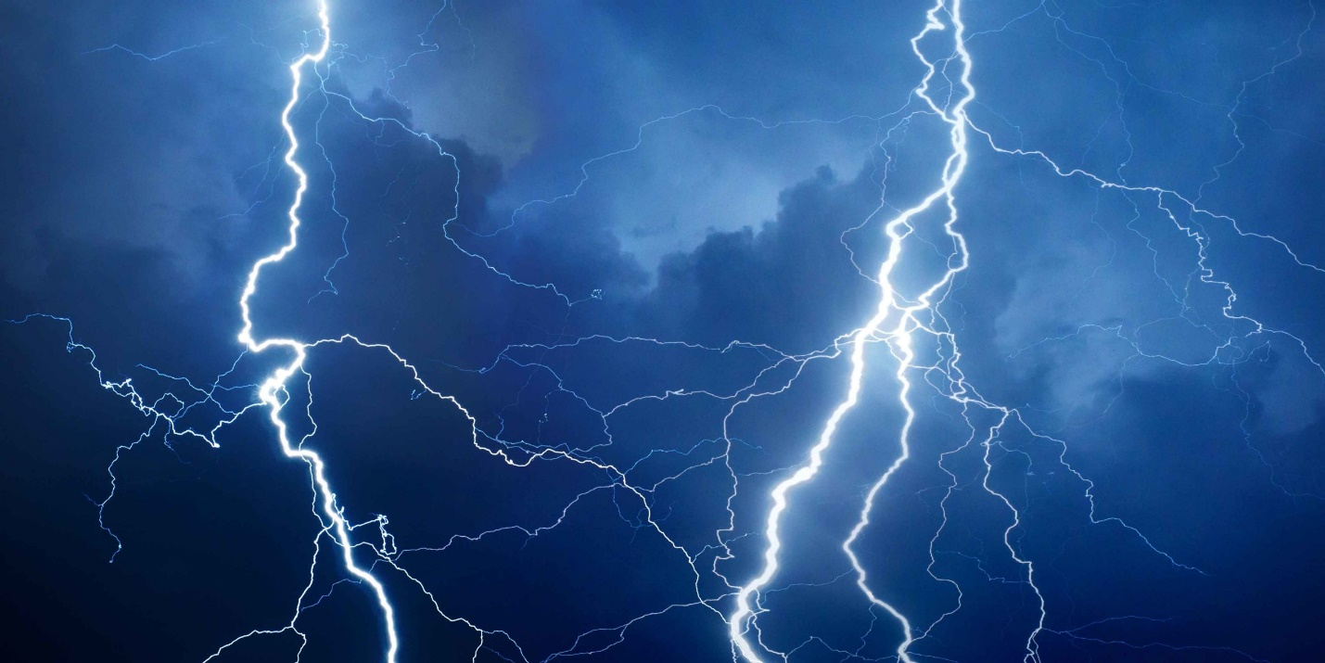

**STORM PREPAREDNESS**