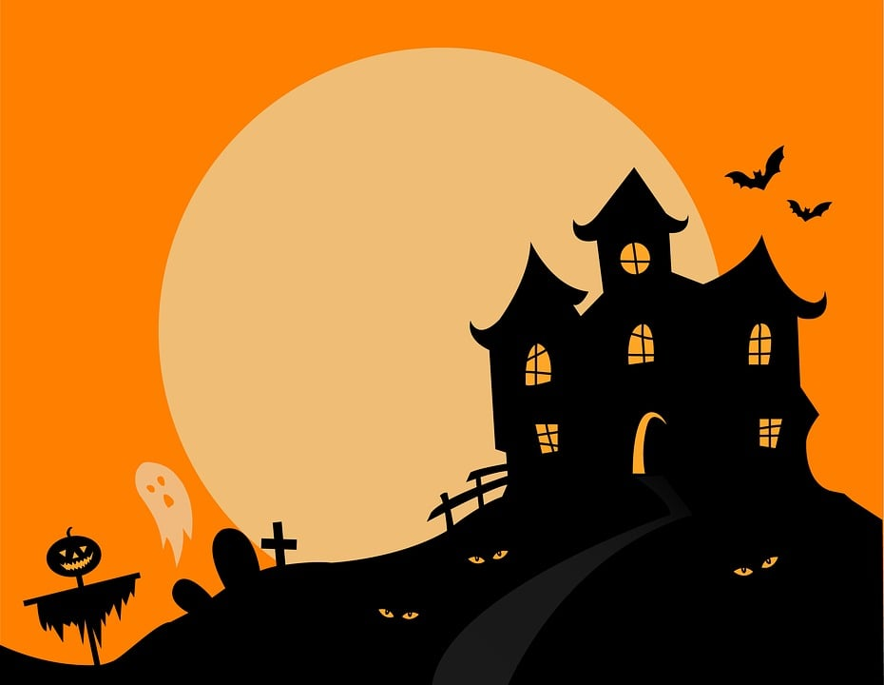

JOIN US FOR SOME TREATS AT THE HALLOWEEN SAFETY CENTER, SPONSORED BY THE BALLWIN POLICE DEPARTMENT, FROM 6-8 ON HALLOWEEN NIGHT AT THE MULTI-PURPOSE AREA AT REBER PARK.