JOIN US FOR THE FUN FAIR AT REBER PARK ON SATURDAY, SEPTEMBER 21, 2024
NOON – 4:00 PM
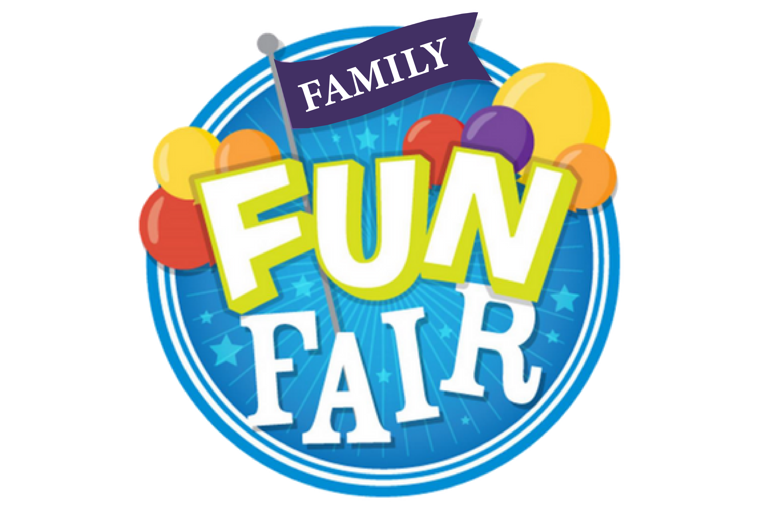
FOOD, GAMES, PRIZES, RAFFLES, AND LOTS OF FUN!

